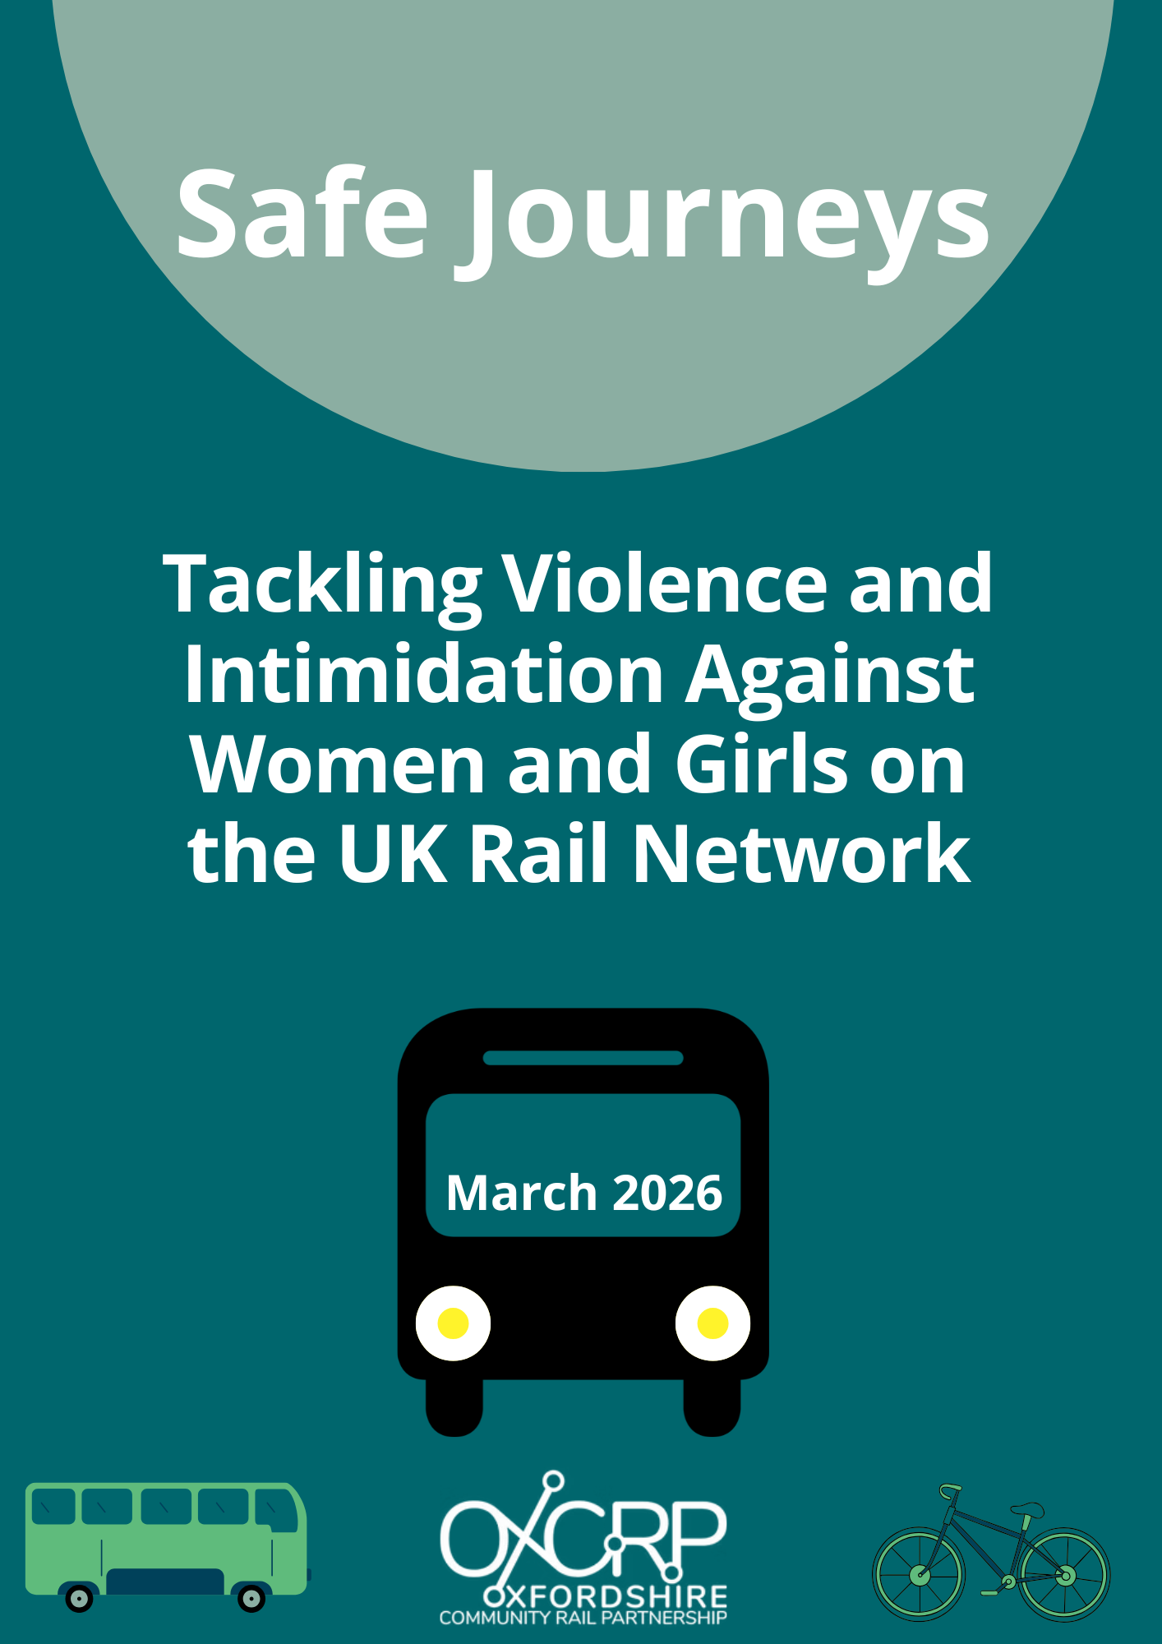

Executive Summary
Violence against women and girls (VAWG) is a pervasive societal issue that affects women and girls across many public, private and community settings. UK data highlight a rising number of reported incidents, reflecting growing concern about women’s safety in shared public spaces. Violence against women and girls on public transport is a growing safety concern across the UK rail network.
Data from the British Transport Police (BTP) show a marked increase in reported incidents in recent years. In 2021, BTP recorded 7,561 violent and sexual offences against female passengers, rising to 11,357 incidents in 2023, an increase of over 50%. There were also over 1908 reports of sexual harassment. BTP survey evidence suggests the issue is widespread, with over one-third of women reporting experiences of sexual harassment or assault while commuting by train or underground services.
Public concern about VAWG is high. A 2025 Rail Delivery Group survey found that 9 in 10 passengers consider VAWG on public transport to be a significant societal issue, and 85% believe the rail industry has an important role in addressing it.
This report presents findings from an Innovate UK–funded EMBODY project, led by the Oxfordshire Community Rail Partnership (OxCRP). The project centred on women’s lived experiences of VAWG on the rail network and translated these insights into practical, evidence-based guidance for frontline rail staff, including the development of an immersive virtual reality (VR) bystander intervention training tool.
The research, conducted between late 2025 and early 2026, combined an online survey with a series of in-person and follow-up focus groups involving women who had experienced or witnessed VAWG on trains and at stations. Participants’ experiences of VAWG on the rail network clustered into four overlapping categories: immediate personal danger; overt intimidation and aggression; covert harassment and intimidation; and a generalised sense of risk to passengers.
A key research finding is that women do not experience these categories as a hierarchy of seriousness. Behaviour often dismissed as “low-level” harassment can have profound emotional and behavioural impacts, leading to fear, hyper-vigilance and decisions to alter or avoid journeys altogether.
An intersectional lens shows that factors such as ethnicity, religion, disability, age, and sexuality can shape both the nature of the harassment experienced and the barriers to reporting it. Recent insights from organisations including Muslims in Rail highlight how visibly Muslim women, particularly those wearing hijabs, often face gendered Islamophobia alongside sexual harassment – experiences that can intensify feelings of vulnerability and exclusion. This aligns with OxCRP’s wider commitment to engaging under-represented communities and ensuring that safety interventions reflect the diverse needs and lived experiences of all women who use the rail network. This work is strengthened when the rail industry, community partners and specialist organisations approach VAWG as a shared challenge, collaborating to develop solutions that draw on the strengths and insights each brings.
Women participating in the research consistently highlighted what would make them feel safer and more supported as users of trains: early, proportionate intervention; a victim-centred, trauma-informed response; visible and confident staff presence; and clear consequences for offenders. Staff who recognise subtle signs of distress and act early – often through low-key, non-confrontational interventions – were seen as pivotal to preventing escalation and reducing harm.

Strategic Recommendations
The evidence from this research points to five clear priorities for action.
1. Publicise, Standardise and Encourage Reporting
Strengthen public understanding of existing safeguarding systems and operational protocols in place to encourage more reporting. Simplify and consistently promote reporting mechanisms across operators, ensure trauma-informed follow-up for victims, and improve data-sharing so incidents are acted.
2. Foster a Zero-Tolerance Culture Through Policy and Training
Introduce effective and meaningful VAWG training for all rail staff, supported by strong leadership and clear messaging that harassment and intimidation of passengers will not be tolerated.
3. Engage Women and Communities in Designing Solutions
Establish ongoing mechanisms – such as Women’s Safety Passenger Groups – to ensure policies, station design, and interventions reflect lived experience and diverse needs.
4. Make Staff Presence a Priority
When possible, increase visible, trained staff on trains and at stations – particularly during evenings and on higher-risk routes to deter offending behaviour, provide reassurance, and enable early intervention.
5. Strengthen Partnerships and Accountability
Deepen collaboration between rail operators, British Transport Police, local authorities, Community Rail Partnerships and specialist organisations, alongside transparent measures to track progress and outcomes.

In summary, tackling VAWG on the rail network is both a moral imperative and essential to building trust in public transport. This report provides a clear, evidence-based blueprint for action. By listening to women’s experiences and acting decisively, the rail industry, partner organisations and communities can create a safer, more equitable network – one where women and girls can travel without fear and with confidence that their safety is taken seriously.

How to cite this report: Oxfordshire Community Rail Partnership (2026). Safe Journeys: Tackling Violence and Intimidation Against Women and Girls on the UK Rail Network. Innovate UK EMBODY Project.

Key terms: violence against women and girls (VAWG); UK rail network; public transport safety; reporting and accountability; staff intervention; staff training; bystander intervention; trauma-informed response; zero tolerance; rail policy.
Contents
Executive Summary 1
Strategic Recommendations 2
1. Publicise, Standardise and Encourage Reporting 2
2. Foster a Zero-Tolerance Culture Through Policy and Training 3
3. Engage Women and Communities in Designing Solutions 3
4. Make Staff Presence a Priority 3
5. Strengthen Partnerships and Accountability 3
Introduction and Context 5
Project Approach and Methodology 7
Key Findings 8
Recognising Subtle Signs of Distress 9
Victim-Centred Approach 9
Addressing Offenders and Ensuring Accountability 10
Building Empathy and Trauma Awareness 11
Encouraging Intervention 12
Strategic Recommendations for the Rail Industry and Policymakers – building on best practice 13
1. Publicise, Standardise and Encourage Reporting 14
2. Foster a Culture of Zero Tolerance through Policy and Training 15
3. Engage Women and Communities in Solutions 17
4. Make Staff Presence a Priority 18
5. Strengthen Partnerships and Accountability 19
Conclusion: Towards Safe and Equitable Rail Travel 19
Project Information and Acknowledgements 20

Introduction and Context
Violence against women and girls (VAWG) is a pervasive societal issue that affects women and girls across many public, private and community settings. VAWG on public transport is a growing safety concern across the UK. Data from the British Transport Police (BTP) show a marked increase in reported incidents on the railways in recent years. In 2021, BTP recorded 7,561 violent and sexual offences against female passengers, rising to 11,357 incidents in 2023, an increase of over 50%. There were also over 1908 reports of sexual harassment. BTP survey evidence suggests the issue is widespread, with over one-third of women reporting experiences of sexual harassment or assault while commuting by train or underground services.
Public concern about VAWG is high. A 2025 Rail Delivery Group survey found that nine in ten passengers consider VAWG on public transport a significant societal issue, and 85% believe the rail industry has an important role in addressing it. There is strong consensus that everyone deserves to feel safe on trains: “Everyone should feel safe on public transport, but all too often that is not the reality for many women and girls,” acknowledged the UK’s Transport Minister in 2025.
This report discusses findings from an Innovate UK–funded EMBODY research project, a consortia of Oxfordshire Community Rail Partnership (OxCRP), Juice Immersive Ltd, British Transport Police, Rail Delivery Group, Chiltern Railways, Rail North Partnership, Maudsley Learning, Transport for the North, Transport for London (TfL), South Western Railway (SWR) and Standing Together Against Domestic Abuse. The research, conducted between late 2025 and early 2026, combined an online survey with a series of in-person and follow-up focus groups involving women who had experienced or witnessed VAWG on trains and at stations.
The project centred on women’s lived experiences of VAWG on the rail network and translated these insights into practical, evidence-based guidance for frontline rail staff. This included the development of an immersive virtual reality (VR) staff intervention training tool, focused on supporting frontline rail staff to feel confident recognising, responding to, and reporting incidents of VAWG. OxCRP's role in the research centred on community voice, ensuring lived experience directly informed the development of the VR training resource. This aligns with OxCRP’s commitment to working with communities, industry partners and local stakeholders to build an inclusive and sustainable public transport system.
Research participants’ experiences of VAWG on the rail network clustered into four overlapping categories: immediate personal danger; overt intimidation and aggression; covert harassment and intimidation; and a generalised sense of risk to passengers. An important finding is that women do not experience these categories as a hierarchy of seriousness. Behaviour often dismissed as “low-level” harassment can have profound emotional and behavioural impacts, leading to fear, hyper-vigilance and decisions to alter or avoid journeys altogether. Many participants reported feeling alone or unsupported – particularly where staff presence was limited, it was dark or in the evening, interventions by staff were inconsistent or ineffective, or reporting routes were unclear or ineffective.
Women participating in the research consistently highlighted what would make them feel safer and more supported as users of trains. These were:
- Clear consequences for offenders.
- A victim-centred, trauma-informed response.
- Early, proportionate intervention.
- Visible and confident staff presence.
Rail staff who recognise subtle signs of distress and act early – often through low-key, non-confrontational interventions – were seen as pivotal to preventing escalation and reducing harm.
This report provides evidence-based insights to inform industry action, support policy influence and guide partnership initiatives. Crucially, it aligns with ongoing efforts aimed at creating a safer, more inclusive rail environment for everyone. Recent additional research by WSP (2022) highlights that when women and girls do not feel safe on trains, or at stations, it limits freedom of movement and opportunities – it affects their commutes to work and education and social lives. This has significant financial implications for the rail industry.

Project Approach and Methodology
The report draws on mixed-methods research conducted by OxCRP between late 2025 and early 2026 as part of the EMBODY project, ensuring that women and girls’ voices are at the heart of identifying solutions.
Pre-Consultation Survey (November 2025): An online survey of 34 women (age 18 and over). Recruitment was through community networks, aiming for diverse representation. Of the 34 respondents, 23 had directly experienced VAWG on public transport and 12 had witnessed incidents. Approximately 1 in 3 had decided not to make a journey by train due to feeling unsafe or uncertain. The survey gathered qualitative descriptions of incidents, feelings of safety while traveling, perceptions of staff presence and suggestions for improvement.
Focus Group Workshops (December 2025): Two in-person workshops were held with 13 women who had reported experiencing and/or witnessing VAWG on trains. These sessions built on the survey findings, allowing participants to discuss their experiences in depth, define key themes, and co-create recommendations for staff training scenarios.
Follow-Up Focus Groups (January 2026): Two additional focus groups with 7 women were convened to review and refine draft VR training scenarios that had been developed from earlier findings. Participants evaluated the realism and effectiveness of these scenarios – which addressed issues like indecent exposure, upskirting and harassment – and provided feedback on how staff interventions in the scenarios could better meet women’s needs.
All participation was voluntary and conducted with informed consent. Given the sensitive nature of lived experience accounts of harassment and violence, the research team took care to ensure anonymity, emotional support for participants, and the use of trauma-informed practices. Personal details have been omitted or changed in this report to protect privacy. The focus is on thematic insights rather than individual stories and any quotations are used with permission to illustrate common experiences.
Researchers conducted a thematic analysis of the survey responses and focus group transcripts. Recurring patterns and cross-cutting themes were identified – such as specific categories of harassment, common environmental factors, emotional impacts, responses by women and others, and desired interventions. These themes shaped the structure of this report.

Key Findings
Research participants discussed four types of VAWG incidents they had experienced or witnessed: immediate personal danger, overt intimidation and/or aggression, covert intimidation and/or aggression, general risk to passengers. These are shown in Figure 1. The matrix identifies specific scenarios – such as predatory behaviour by “normal” appearing men in the covert/personal danger quadrant, or the broader environmental risks posed by intoxicated crowds and seat disputes in the overt/general risk quadrant.
Figure 1. VAWG Experience Matrix on the Rail Network
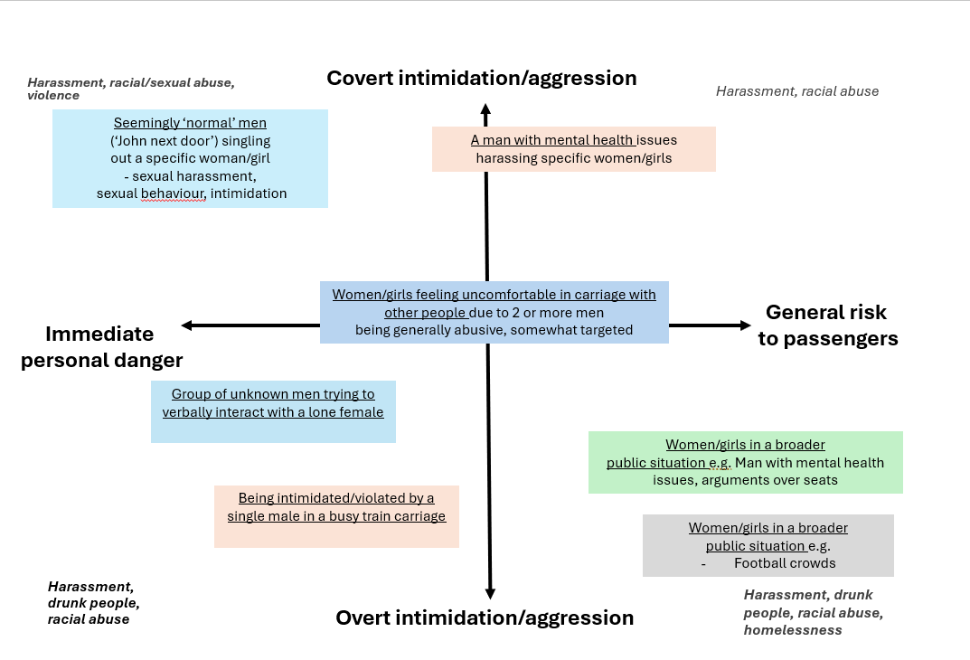
By mapping these behaviours, Figure 1 highlights that VAWG on the rail network ranges from targeted, high-risk predatory stalking to broader, systemic public disorder, each requiring different levels of intervention and bystander awareness.
One of the aims of the research was to translate women’s experiences and suggestions into practical guidance for rail staff training. The research findings highlight women’s experiences of VAWG, with clear recommendations for how staff can be trained and supported to supportively and sensitively respond to VAWG incidents. These are explored in more detail in the following sections, within the context of existing examples of good practice.

Recognising Subtle Signs of Distress
Women in the focus groups stressed that they would like staff to be able identify when a passenger is uncomfortable before a situation escalates. Because women often try to avoid drawing attention – for instance, by “freezing,” keeping their heads down, or pretending to be on their phone – overtly obvious cries for help can be rare. They would like staff training to highlight subtle cues of distress or fear: body language like a woman moving away from someone, looking anxious or cornered, or trying to catch a staff member’s eye in an unusual way. If staff learn to trust their instincts and proactively check in (even with a simple “Are you okay?” or a friendly presence), it can offer support.
The participants want staff to step in before harassment escalates. They appreciated non-verbal and low-key interventions – for example, a staff member casually positioning themselves nearby or asking the woman if she needs help in a subtle way or offering an easy escape route, rather than immediately confronting the offender in a manner that could spark aggression. Sometimes just the presence of a concerned staff member can deter a perpetrator. Women felt that there often were too few staff on the rail network and that this can exacerbate the problem.
“There needs to be better staffing on each carriage. All… every single story, it's an empty carriage with no staff. Why are men picking those carriages? Because they know there's no one there to challenge them.”
“Just the power of a member of staff walking by is so disruptive for the offender, and so reassuring for the victim.”
Staff training needs to emphasise a range of intervention tactics, from discreet check-ins to safe verbal commands if necessary. Women and girls’ wellbeing in these situations and focusing on deescalation need to be prioritised.

Victim-Centred Approach
A recurring theme in the research was that any official response must put women and girls’ safety and dignity first: “the focus needs to be on [the victim]”. Women expressed frustration at being the ones who must move or interrupt their journey, and the lack of support they sometimes had experienced from staff.
“I called the guard to assist me. The guard refused to help me even though I was clearly upset and had ripped clothes. I insisted the police were called at which point the boys threw my necklace onto the ground. The guard said I should now get back on the train as they no longer had my necklace. I was so shocked that I just got back onto the train to complete my journey. The guard did not care about what had happened to me and was just concerned that the train was not delayed. The guard just let the boys go off and did not support reporting the matter to police.”
Women also acknowledged that sometimes removing the victim from the threat may be the quickest way to ensure immediate safety. Staff training should teach “safeguarding first” – for instance, once an incident is identified, ensuring the affected woman or girl is guided to a safe location (perhaps a different carriage or the staff area) and not left alone with the aggressor.
“I think having more staff visible and on trains would help. I might have said I felt uncomfortable in the first instance and asked the staff member to accompany me as I moved seats. Just knowing someone was aware of the situation would be comforting. Equally it must be threatening for staff too and no one wants to get attacked just doing their job!”
“The introduction of train Marshalls who patrol the train perhaps on more ‘active’ routes for crime or intimidation [could be helpful].”
Women wanted staff to convey empathy, reassure the victim that she is not at fault, and offer practical support – such as staying with her, contacting police or friends, providing water and a calm environment. This approach can greatly reduce trauma.

Addressing Offenders and Ensuring Accountability
Women want offenders to face consequences, but they also worry about backlash during an intervention. Staff training needs to clarify how to confidently address perpetrators when needed – for example, using a firm but professional tone to state that certain behaviour is unacceptable and must stop. The experiences of female rail staff also need to be considered, with the need to protect them when at risk from perpetrators. There is little research on female rail staff’s experiences in the UK, however industry surveys and union data suggest that female staff experience significant levels of harassment and violence.
“Please listen if we’re brave enough to say out loud that we don't feel safe. We normally spend enough time telling ourselves we’re being paranoid before getting to the point of talking to someone about it.”
“I have seen some train staff be quick to anger and very emotional, that makes me worry that they won’t be able to de-escalate a dangerous situation.”
In more dangerous situations, staff should know how to quickly alert the BTP or station security, using codes or discreet communication to avoid inflaming the situation further. The research suggests that staff may sometimes need to work in teams or call for backup to intervene safely if a harasser is aggressive or if dealing with a group of offenders.
“Having a presence on the train, walking up and down the carriages etc. making it obvious there are workers who have a responsibility on the train for safe travel.”
“Somebody to be monitoring CCTV, and if it's sort of seen that somebody's acting erratically, maybe at the next station, somebody might get on and kind of intervene and ask if everything's okay.”
While CCTV monitoring infrastructure is already in place across much of the rail network, this participant’s perspective highlights an important gap between existing operational safeguards and public awareness of them. Strengthening communication about the safety systems and protocols already in operation – including CCTV monitoring, staff reporting procedures and real-time response capabilities – could help to improve passenger confidence and provide greater reassurance, particularly for women travelling alone or during quieter periods.
Training should include de-escalation techniques used in other contexts. Research participants pointed to how airline cabin crews firmly handle unruly passengers. Ultimately, women want to see that offenders are caught, removed or penalised so that justice is served and unacceptable behaviour is not tolerated.
“An automatic ban if you are found guilty of committing a violent crime. A new style of gate that will not allow two people at once and perhaps holds the people in place until staff come along.”

Building Empathy and Trauma Awareness
The research participants felt that will be able to intervene more effectively if they truly understand the perspective of victims.
“They could put themselves in… in the situation of, like, the public, so, like be in our shoes at that time? How would they feel in that situation?”
This is where immersive VR training can be especially powerful. By “putting staff in the shoes” of female passengers facing harassment, VR can drive home the emotional impact of these incidents and the importance of a sensitive, timely response. The participants wanted staff to understand that “low-level” harassment can feel extremely serious to the person experiencing it and that their intervention can deescalate situations. They felt that empathy and understanding, combined with practical skills, will give staff the confidence to act as supportive allies rather than passive bystanders.
“Actually just say, look, you know, the way you're behaving right now is making people feel uncomfortable, and if you carry on, then you will be asked to leave the train. I honestly believe that in quite a lot of cases, that would be enough.”

Encouraging Intervention
Participants felt that the rail industry can empower all passengers to play a role in making trains safer. The research suggests public-awareness measures (posters, announcements, etc.) should promote a culture where everyone feels responsible for each other’s safety. The lack of support and/or intervention by other passengers was a common experience.
“No one said anything. No one was like, you know, what are you doing? So I think that shocked me as well, because I'm like, I've just openly outed this person, and no one… and I was traveling alone that day as well, no one has said, like....You know, what are you doing?”
“It felt as though they [bystanders] were looking at me like I had done something to this man, I deserved it. It was a weird… and that's why I still remember to this day […] no one did a thing.”
There is growing momentum across the transport industry to promote active bystander intervention. In October 2025, Transport for London (TfL) launched its Act Like a Friend campaign, encouraging passengers to support fellow travellers targeted by hate crime, sexual offences and harassment. The campaign features a video shown in cinemas and on ITVX depicting three true stories of bystanders who helped defuse incidents by engaging targeted passengers in conversation, complemented by posters across the TfL network sharing further real bystander stories with practical conversation starters. A parallel campaign targeting perpetrators features messaging on the consequences of committing crime on the network. TfL also funded hundreds of free places on active bystander training sessions delivered by the charity Protection Approaches. This initiative demonstrates a growing emphasis on culture change and aligns with the research participants’ ideas for action. Women felt that more could be done to make it clear how passengers can safely intervene or get help, for example, discreetly texting BTP to report harassment. If rail staff are trained to model positive intervention and if official channels respond swiftly to reports, bystanders will be more likely to act as well.

Strategic Recommendations for the Rail Industry and Policymakers – building on best practice
The research highlights that improving the safety of women and girls on the rail network is not only a moral imperative to improve safety but also key to supporting confidence in, and increasing use of, public transport. A collective effort can turn the tide against the normalisation of harassment and the increasing levels of VAWG on public transport.
The rail industry already has begun to respond to increasing levels of VAWG on public transport and there are examples of good practice. Rail Delivery Group commitments include:
- Increasing body-worn cameras on trains, with nearly 19,000 now in use by staff.
- Introducing mandatory and consistent training for all rail staff to better recognise and safely respond to sexual harassment.
- Creating dedicated passenger groups across the UK focused on women and girls’ safety.
- Establishing forums for women to contribute to designing new stations and carriages with safety in mind.
The evidence-based insights from the research highlight strategic priorities for rail industry leaders, transport authorities and policymakers. Research participants discussed their experiences of VAWG, the impacts of these incidents, what they had seen working to tackle these incidents, and recommendations for improving the safety and wellbeing of women and girls on the rail network. These are summarised in Table 1, with examples of good practice that can be built upon.
Table 1. Summary of Key Findings, Recommendations, Implementations and Case Studies
Lived Experience Theme | Key Findings | Recommendations | Implementations | Case Study Examples
Under-Reporting & Silencing | Fear nothing will happen | Publicise, standardise and encourage reporting | Promote 61016; trauma-informed follow-up | 61016 text service (BTP); Project Guardian (London)
Systemic Tolerance | Harassment not taken seriously | Foster zero tolerance culture | Mandatory training; leadership accountability | Speak Up Interrupt (BTP); Enough Campaign (UK Gov); GTR Active Bystander Training
Victim Isolation & Design | Women feel vulnerable at night | Engage women and communities | Women’s Safety Groups; inclusive design | Women’s Night Safety Charter (London); Angel Project (Gloucestershire, community co-design)
The Staffing Gap | Women feel less safe with fewer staff | Make staff presence a priority | Travel Safe Officers; BTP patrols; CCTV monitoring | Project Servator (BTP); Project Shield (North East); Angel Project (Gloucestershire)
Lack of Accountability | Weak oversight | Strengthen partnerships | Multi-agency hubs; public reporting | Project Guardian partnerships; Railway Guardian programme.

1. Publicise, Standardise and Encourage Reporting
Under-reporting of harassment and even assault remains a huge challenge – many women do not report incidents because they doubt anything will come of it, and/or they fear not being believed. The rail industry should continue efforts to simplify and promote reporting channels. For example, the BTP’s 61016 text service should continue to be widely advertised on trains and at stations. Additionally, as pledged by rail companies in 2025, establishing a unified reporting and data-sharing system across all train operators will help ensure reports do not fall through the cracks.
Consistent follow-up is key. When women report VAWG, they need to receive feedback and support – for example, trauma-informed follow-up care and information on outcomes – so they know their voices are heard. Greater reporting and data collection will also enable better targeting of resources, as hot-spot locations and times can be identified and addressed proactively.
A key example of improving reporting mechanisms on the rail network is BTP’s 61016 text service, supported by the See it. Say it. Sorted. campaign. This service enables passengers to report incidents discreetly via text, which is particularly important in cases of harassment or intimidation where speaking openly may not feel safe. However, evidence suggests that barriers to reporting persist among some groups. For example, the Muslim Safety on UK Public Transport report found that only 12.5% of incidents experienced by Muslim passengers are reported, and nearly 70% of those who did report felt their case would not be taken seriously. This reinforces the need not only to promote reporting tools, but to ensure consistent, trauma-informed follow-up and improved communication about outcomes. While reporting infrastructure is in place, strengthening trust in the system remains a critical challenge.

2. Foster a Culture of Zero Tolerance through Policy and Training
The industry, in coordination with government and law enforcement, should continue to embed a stronger zero-tolerance stance on VAWG. This involves clear policies and passenger communications that harassment and misogynistic behaviour will be addressed with real consequences (e.g. fines, bans, police intervention). It needs to be comparable to the way physical assault or racist abuse is dealt with. The 2025 Rail Delivery Group commitments are a step in the right direction. These include:
- Introducing mandatory and consistent VAWG training for all rail staff to better recognise and safely respond to sexual harassment.
- Appointing executive-level leads for women’s safety in every train operating company.
- Hosting an industry-wide conference dedicated to addressing VAWG on public transport.
Ensuring that these commitments are fully implemented and sustained is crucial. Additionally, the rail sector should coordinate with the wider national strategy on VAWG, aligning with initiatives like the UK Government’s Tackling VAWG Strategy (2021) and the cross-industry Enough campaign. By harmonising messages and efforts, the rail industry can amplify its impact on overcoming VAWG.
Efforts to embed a zero tolerance culture are further reflected in TfL’s and BTP’s campaigns encouraging passengers to act as active bystanders when witnessing harassment, providing clear guidance on safe intervention and reporting. Project Guardian was an example of a multi-agency initiative designed to tackle sexual harassment across public transport, including rail. It combined targeted enforcement, awareness campaigns and specialist training for officers in handling sexual offences. The project was introduced following evidence that up to 90% of incidents of unwanted sexual behaviour on public transport were not reported. Following its introduction, reporting of sexual offences increased substantially, indicating both improved confidence in the system and greater visibility of the issue.
Leadership, training, and consistent messaging can begin to challenge systemic tolerance of harassment, although increases in reporting also highlight the scale of previously hidden incidents. Coordinated, multi-partner campaigns aim to shift social norms and reinforce that inappropriate behaviour will not be tolerated. Translating this into consistent frontline practice across all operators remains an ongoing challenge for the industry.

3. Engage Women and Communities in Solutions
Ongoing, regular engagement with women, girls and community stakeholders is essential. The formation of dedicated Women’s Safety Passenger Groups, as committed to in 2025, provides a platform for continuous dialogue. These Groups can advise on station design (for example, improving lighting, sightlines and safe waiting areas), service improvements (such as trialling women-only carriages or compartments, if supported by evidence), and review progress of safety initiatives. Community rail partnerships and advocacy groups (including those representing diverse women’s experiences) should be included in planning and decision-making. Their input will help to ensure that interventions are culturally sensitive, address the needs of all women (including young women, women of colour, LGBTQ+ individuals, and those with disabilities who may have distinct safety concerns), and avoid unintended consequences.
The Angel Project in Gloucestershire provides a practical example of a locally developed, community-led model, combining volunteer patrols, safe spaces and support on transport routes. Developed in response to local concerns about women’s safety in public spaces, the initiative combines volunteer-led “Night Angels” patrols, a network of Safe Spaces in local businesses and a developing “Train Angels” presence on regional rail routes. The model is explicitly shaped by lived experience, focusing on visibility, reassurance, and immediate support for those who feel unsafe. Volunteers patrol high-risk periods, offering safeguarding, first aid, and assistance with onward travel, while safe venues provide refuge. Operational data indicate that the scheme has responded to numerous incidents and contributed to improved perceptions of safety among local women.
The Angel Project case study highlights the value of co-design and community ownership, particularly in addressing gaps between formal policing and everyday passenger experience. This aligns with wider sector insights, including WSP’s work on inclusive travel, which highlights how transport systems have historically been designed without fully reflecting the lived experiences of women and diverse groups, resulting in safety gaps. WSP’s report found that 8 in 10 transport professionals are male and 46% have never considered gender in their day-to-day work, raising fundamental questions about how transport systems can be made safe and accessible for women. The report recommends easier reporting mechanisms, physical interventions in lighting, CCTV and natural surveillance, with all of this needing to be considered from the outset of the design process.
Embedding mechanisms such as Women’s Safety Passenger Groups and co-design processes also can help ensure that interventions are shaped by those most affected. While grassroots initiatives like the Angel Project demonstrate the value of this approach, there is a need to scale and systematically embed community engagement across the rail network.

4. Make Staff Presence a Priority
Research participants would like to see an increase in visible staffing at stations and on trains, especially during evenings and on routes identified as higher-risk. This could involve deploying roving conductors or “Travel Safe Officers” in carriages and at key stations. Trained staff can deter potential offenders but their presence provides reassurance to passengers.
Visible staff presence remains one of the most consistently cited factors influencing perceptions of safety on the rail network. BTP deliver this through a combination of uniformed patrols, plainclothes operations, and targeted deployments during evenings and weekends. For example, late-night policing operations are routinely conducted in response to passenger demand, particularly on higher-risk routes and at key stations. Exploring partnerships with BTP for more regular patrols (both uniformed and plainclothes) and leveraging technology, e.g. real-time CCTV monitoring and timely dispatch of security to trouble spots, are crucial. Ultimately, a visible staff presence fulfils the dual purpose of prevention and rapid response.
These approaches can be complemented by initiatives such as Project Servator, which uses unpredictable, high-visibility patrol patterns to deter offending and increase public reassurance. Evidence suggests that such deployments not only enable rapid intervention but also contribute to increased reporting and perceived safety among passengers. Industry commitments emphasise the importance of visible staff presence and coordinated action.

5. Strengthen Partnerships and Accountability
As the examples and case studies highlighted in this report show, partnership working is central to efforts to address violence against women and girls on the rail network. No single organisation can address VAWG in isolation. By integrating data, aligning messaging and coordinating operational responses, multi-agency models can create a more consistent and accountable system. However, evidence suggests that while collaboration structures are well established, there is limited transparency around outcomes and long-term impact, highlighting the need for clearer accountability frameworks and shared performance measures. Tracking and publicly reporting progress on measures like staff VAWG prevention training and incident response times can help maintain momentum. Leadership from the top is vital, with senior VAWG safety champions (as pledged) being seen to drive these efforts.

Conclusion: Towards Safe and Equitable Rail Travel
The experiences shared by women through this project make one reality unmistakably clear: there is an opportunity for the rail industry and its partners to further improve travel experiences for women and girls by creating environments that are consistently safer, more inclusive and supportive. This research, and the case studies highlighted, demonstrate that change is both possible and achievable.
There is growing momentum across the UK rail sector to address violence and intimidation against women and girls – from national policy commitments and industry leadership to innovative approaches such as OxCRP’s immersive VR staff intervention training. Women themselves have articulated clearly what makes a difference: early and proportionate intervention, trauma-informed responses, visible and confident staff presence, and meaningful consequences for perpetrators. Recent industry and research evidence highlights both progress and ongoing gaps. The path forward is clear. By acting on the evidence and recommendations set out in this report the rail industry can move decisively from commitment to delivery. This is not simply a matter of perception or reassurance. It is about ensuring that safety is real, consistent and felt by those most affected. As one research participant noted, “I always hear announcements saying abuse to staff will not be tolerated… can we incorporate that abuse to fellow passengers will not be tolerated?” The findings and recommendations in this report provide a clear blueprint for action. There is now an opportunity for rail leaders, policymakers and partners to implement them with urgency, consistency and resolve – so that women and girls can travel freely, confidently and without fear on the UK rail network.

Project Information and Acknowledgements
This EMBODY research project was funded by an Innovate UK First of A Kind (FOAK) project addressing Violence and Intimidation Against Women and Girls (VIAWG) on the rail network. The project involves the creation of an immersive, trauma-informed Virtual Reality (VR) training tool to equip frontline rail staff with the confidence and skills to recognise, de-escalate, and report VIAWG incidents. OXCRP would like to thank Innovate UK for funding the project, the co-delivery partners for their commitment and collaboration, and all of the women who took part in community voice workshops and completed the survey and sharing their experiences.

British Transport Police Fund: statement of accounts 2023 to 2024 - GOV.UK
Survey finds over third of women sexually harassed on their commute | British Transport Police
85% say Rail has role in tackling Violence against women and Girls: Industry sets out Safety Commitments | Rail Delivery Group News
British Transport Police Fund: statement of accounts 2023 to 2024 - GOV.UK
Survey finds over third of women sexually harassed on their commute | British Transport Police
85% say Rail has role in tackling Violence against women and Girls: Industry sets out Safety Commitments | Rail Delivery Group News
As above
https://www.wsp.com/en-gb/insights/towards-inclusive-travel-tackling-transport-gender-bias
International Transport Workers’ Federation (2019). Women Railway Workers’ Survey Report; Rail Safety and Standards Board (2021). Work-Related Violence Survey for Rail Staff.
Creating a Safer Transport Network for Everyone - Made by TfL blog
85% say Rail has role in tackling Violence against women and Girls: Industry sets out Safety Commitments | Rail Delivery Group News
Muslim Safety on UK Public Transport Report - Muslims In Rail
Transport for London (2014) Report it to stop it: tackling unwanted sexual behaviour on London’s transport network (Project Guardian results); 'Report it to Stop it' increases public confidence to report unwanted sexual behaviour - Transport for London
https://www.safespacescheme.org/
Towards inclusive travel: tackling transport’s gender bias | WSP
https://www.transportforthenorth.com/wp-content/uploads/Safety-and-public-transport-research.pdf

